Question 14:
Build a dictionary of five countries and their currency names. Use if-else to check if India is included.
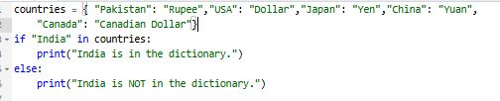
Output:

